SALESTORM
Core Requirements Specification — High-Scale E-Commerce Flash Sale
Version 1.0 · 5 October 2026

Contents
- Introduction · 2. Scope · 3. Stakeholders and roles · 4. Assumptions · 5. Business rules
- Functional requirements · 7. Non-functional requirements · 8. Architecture overview and technology
- Data requirements · 10. Worst-case scenarios and solutions · 11. Acceptance scenarios
- Design constraints and principles · 13. Open questions · Appendices (glossary, image sources, evidence and provenance, references)

1. Introduction

1.1 What this document is
This document explains what SALESTORM must do, how well it must do it, and what can go wrong when thousands of people try to buy the same limited product at the same moment. It is the starting point for the architecture, database, API and reliability designs that follow.
In plain words: a flash sale is like opening the doors of a shop with only 100 items on the shelf while 10,000 people are pushing at the door. Our job is to let the right 100 people in, never promise an item twice, take payment safely, and still behave sensibly if something breaks.

1.2 Business context
SALESTORM is a high-volume e-commerce platform that runs limited-stock flash sales. Within seconds of a sale starting, a huge number of customers try to buy the same product. At the same time, the payment gateway, the database and the other services behind the scenes may slow down or fail.
The scenario this whole document is built around:
Parameter | Value
Available inventory (Product X) | 100 units
Simultaneous purchase requests | 10,000
Payment success rate | 95%
Payment failure rate | 5%
Duplicate request rate | 2% (about 200 requests)
Order Service outage | 30 seconds
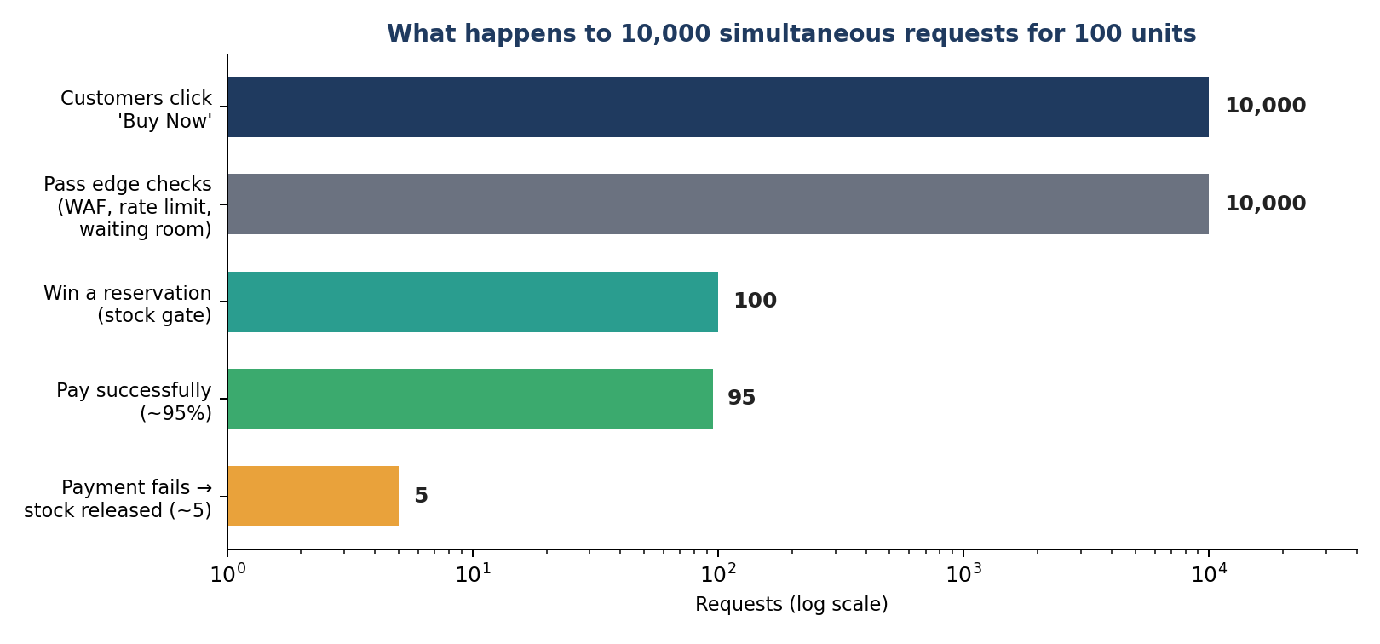
What happens to 10,000 simultaneous requests for 100 units (generated diagram)

1.3 The problem
A normal online shop can fall over during a flash sale. Thousands of simultaneous requests can overload application servers, databases and payment services. If concurrent stock requests are not controlled, more units can be sold than exist. A nervous customer who taps “Buy” twice can create two reservations, two payments or two orders. And if payment succeeds just as the Order Service is briefly down, the platform can forget that a customer has paid.

1.4 The key question
How can the platform handle 10,000 simultaneous purchase requests for only 100 units without overselling, creating duplicate payments or losing valid orders?

1.5 Business objectives and success criteria
ID | Objective | How we know it worked
BO-1 | Survive sudden traffic surges | No system collapse at peak; excess traffic is queued or politely rejected
BO-2 | Never oversell | At most 100 sales for 100 units
BO-3 | Hold stock temporarily, then release it | Unpaid or expired holds return to stock exactly once
BO-4 | Take payments safely | One charge per purchase, even with retries
BO-5 | Keep a correct, traceable order lifecycle | Every paid purchase ends in a valid order
BO-6 | Recover from failures | Every failure has a defined recovery path
BO-7 | Be buildable and operable | Engineers can understand, implement and run it
Expected result for the main test scenario:
Measure | Target
Successful reservations | at most 100
Confirmed orders | at most 100
Negative inventory events | 0
Duplicate reservations | 0
Duplicate payments | 0
Successful payments lost after recovery | 0

2. Scope

2.1 The customer journey we are designing
Customer → Product Discovery → Cart → Inventory Check → Inventory Reservation → Checkout → Payment → Order → Fulfilment → Shipment → Notification → Delivery Tracking
This includes sign-in, product and sale pages, cart, stock checks, temporary reservations (with expiry and release), checkout, payment (success, failure and timeout), order creation and state changes, fulfilment and shipment events, notifications, delivery tracking, duplicate-request protection, failure recovery, and logging, metrics and tracing.

2.2 What we are not building
- A complete production shop front-end
- A real banking or card network, or storage of raw card details
- Warehouse robotics or a real courier network
- Detailed tax-law calculation
- Recommendation and search-ranking algorithms
- Multi-region active-active deployment (described only as a future step)
- Full customer-support tooling
These are treated as external services or simplified components.

3. Who cares about this system
Stakeholder | What they need
Customers | A fair, fast, clear answer, and never a double charge
Business management | Maximum sales without overselling or lost revenue
Inventory team | Accurate stock numbers
Payment and finance teams | Safe payments, no duplicate charges, clean reconciliation
Order management team | Valid, traceable orders
Fulfilment team and delivery partners | Confirmed orders and valid shipment requests
Customer support | Visibility into failed payments, refunds and delivery problems
Platform engineering and operations | A system they can scale, monitor and repair
Security and compliance | Protected customer and payment data

3.1 Roles and permissions
Capability | Customer | Support | Sale admin | Warehouse | Finance | System
Browse products and sale | Yes | Yes | Yes | Yes | – | –
Manage own cart | Yes | View | – | – | – | –
Reserve stock | Own | – | – | – | – | Expiry / release
Pay | Own | – | – | – | – | –
View orders | Own | All | All | All | All | –
Cancel order | Own (rules apply) | Yes | Yes | – | – | –
Configure sale, stock, price | – | – | Yes | – | – | –
Update fulfilment | – | View | – | Yes | – | Courier events
Refund and reconcile | – | Request | – | – | Yes | Yes
View audit logs | – | – | Yes | – | Yes | –

4. Assumptions
Each assumption carries a basis so that readers can see where it comes from: Given (stated in the problem brief), Team brief (supplied by the team’s own requirements text), Established practice (widely documented engineering practice, see Appendix C), or Team assumption (a judgment call that should be validated by testing).
ID | Assumption | Basis
A-01 | Product X starts with 100 sellable units. | Given
A-02 | Up to 10,000 customers may try to buy it at the same moment. | Given
A-03 | Each customer may buy at most one unit (configurable). | Team brief
A-04 | A reservation lasts 5 minutes and is released automatically if unpaid. | Team brief
A-05 | About 95% of payments succeed and 5% fail. | Given
A-06 | About 2% of requests are duplicates (double-clicks, retries). | Given
A-07 | The Order Service can be unavailable for up to 30 seconds. | Given
A-08 | The payment provider can time out or answer late. | Established practice (external calls fail)
A-09 | Product information can be cached; reserving stock needs strong consistency. | Established practice
A-10 | Browsing may show slightly stale stock; the stock service always makes the final decision. | Team assumption
A-11 | The payment provider supports an idempotency key or merchant transaction reference, status lookup and webhooks. | Team assumption: must be confirmed for the chosen provider (Stripe documents idempotency keys, R1)
A-12 | Customers must sign in before reserving limited stock. | Team assumption
A-13 | All client and service traffic uses HTTPS/TLS. | Established practice
A-14 | Notifications and delivery tracking never block order confirmation. | Established practice (outbox / async messaging, R2)
A-15 | Payment and shipment providers can be briefly unavailable. | Established practice
A-16 | Important business events are written to an audit trail. | Team assumption
A-17 | The sale start time is known in advance, so caches can be warmed and capacity added beforehand. | Team assumption
A-18 | A single primary region with multiple availability zones is used. | Team assumption

5. Business rules
These are the rules that must hold no matter what happens.
ID | Rule | In plain words
BR-01 | Successful reservations and confirmed sales never exceed available stock. | 100 units means at most 100 buyers.
BR-02 | available_quantity >= 0 always. | Stock can never go below zero.
BR-03 | One unit per customer during the sale. | No hoarding.
BR-04 | A reservation unpaid after 5 minutes expires and releases its unit. | Abandoned baskets do not lock stock forever.
BR-05 | A reservation can release stock only once. | A retry can never create phantom stock.
BR-06 | The same purchase request with the same idempotency key returns the original result. | Double-click, same answer.
BR-07 | Repeating a payment request never creates a second payment. | No double charge.
BR-08 | A payment counts only after the server receives a valid confirmation from the provider. | The browser saying “paid” is not proof.
BR-09 | An order is confirmed only after successful payment and a valid reservation. | No order without money and stock.
BR-10 | Orders and reservations move only through defined states. | No jumping from “created” to “delivered”.
BR-11 | Important reservation, payment, order and stock events are audited. | Every disputed case can be reconstructed.
BR-12 | Raw card details are never stored. | Card entry happens on the provider’s hosted, redirect or embedded page, which greatly reduces (but does not remove) our PCI DSS scope (R11).

6. Functional requirements
Priority: M = must have, S = should have, C = could have.

6.1 Customer and access
ID | Requirement | Pri
FR-01 | Customers register or sign in before taking part in the sale. | M
FR-02 | Every cart, reservation, checkout and order action checks that the customer is authorised. | M
FR-03 | A customer cannot reserve more than the allowed quantity. | M
FR-04 | Role-based access for customer, support, sale admin, warehouse and finance. | M

6.2 Product discovery
ID | Requirement | Pri
FR-05 | Customers can browse and search products by category. | M
FR-06 | Sale pages show price, start and end time, and purchase limit. | M
FR-07 | Product pages and static assets are cached and served without touching the transactional database. | M
FR-08 | A stock indicator (such as “selling fast” or “sold out”) may be approximate; the Inventory and Reservation Service has the final say. | M
FR-09 | A countdown is shown before the sale, and “Buy Now” is enabled only while the sale is live. | S

6.3 Cart
ID | Requirement | Pri
FR-10 | Customers can add, change and remove cart items within sale rules. | M
FR-11 | Price, eligibility and quantity are revalidated at checkout. | M
FR-12 | Adding to the cart does not reserve stock unless a reservation is explicitly created. | M
FR-13 | Flash-sale products support a direct “Buy Now” that skips the cart. | M

6.4 Traffic control
ID | Requirement | Pri
FR-14 | The edge applies WAF rules, bot protection and rate limits per IP, session and user. | M
FR-15 | The system controls how many requests enter the purchase flow at peak. | M
FR-16 | A waiting room or queue holds customers who cannot enter yet and shows their position or status. | M
FR-17 | Admitted customers may receive a short-lived admission token. | S
FR-18 | Once stock reaches zero, a sold-out flag rejects new requests before they reach the stock store. | M
FR-19 | Customers are told clearly when stock is sold out. | M

6.5 Inventory check and reservation (the critical part)
ID | Requirement | Pri
FR-20 | Checking stock and reserving it happen as one atomic, concurrency-safe operation. | M
FR-21 | Simultaneous requests can never reserve the same unit. | M
FR-22 | With one unit left and many requests, exactly one succeeds and the rest get a clear sold-out response. | M
FR-23 | Stock is tracked as total, available, reserved and sold, and available + reserved + sold = total always holds. | M
FR-24 | Any operation that would make available stock negative is rejected. | M
FR-25 | Each reservation has a unique ID, customer, product, quantity, status, expiry time and idempotency key. | M
FR-26 | Reservation statuses: RESERVED, PAYMENT_PENDING, CONFIRMED, PAYMENT_FAILED, EXPIRED, CANCELLED, RELEASED. | M
FR-27 | Expired reservations release their stock automatically. | M
FR-28 | A failed payment releases the reservation. | M
FR-29 | Release is conditional and idempotent: it never releases a confirmed or already-released reservation. | M
FR-30 | Repeating the same purchase request never creates a second reservation. | M
FR-31 | Creation, confirmation, expiry, release and cancellation of a reservation are audited. | M
FR-32 | A reconciliation job finds and repairs differences between stock counters and reservation records. | M
FR-33 | Released units can be offered to a waitlist in order. | C
FR-34 | Admins can load, adjust and freeze stock, with an audit record. | M
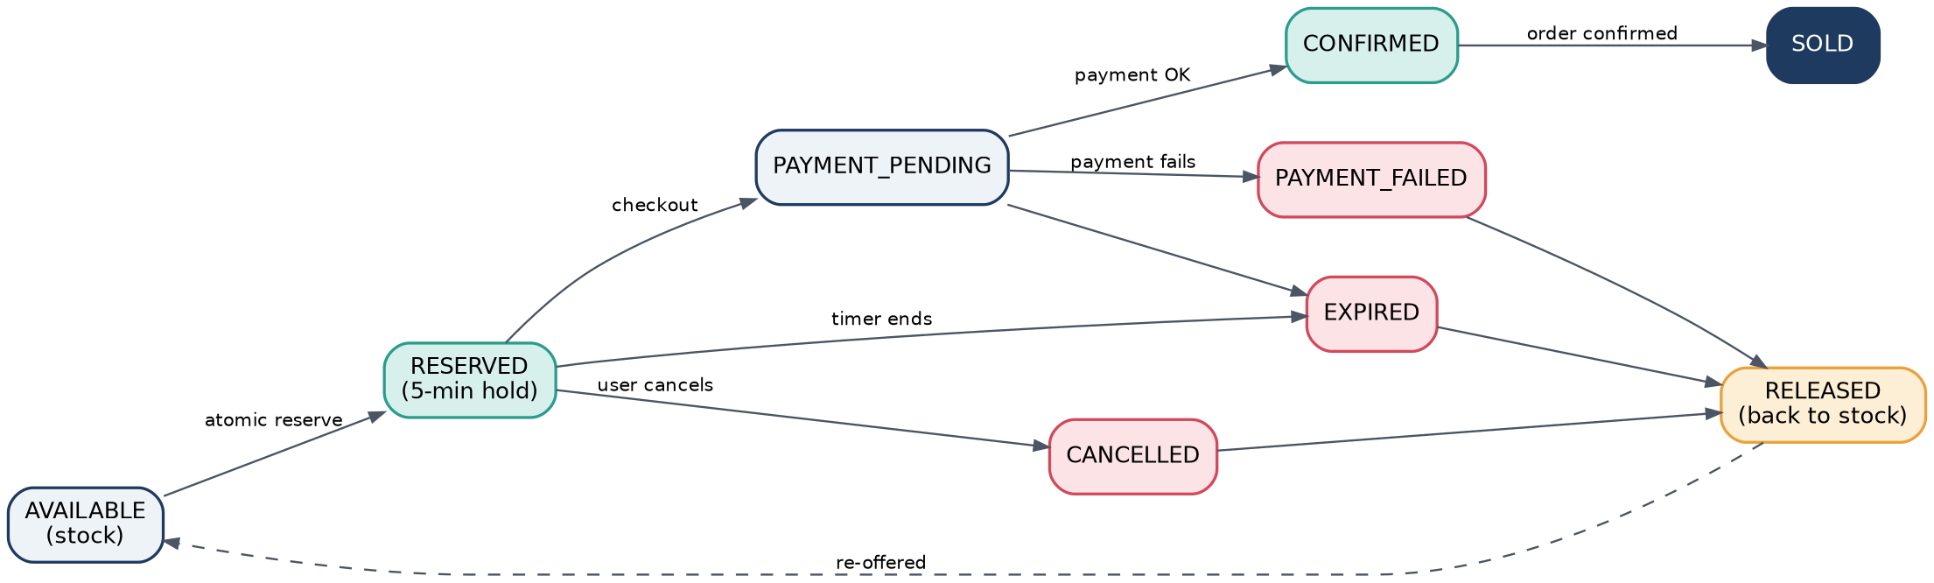
Reservation lifecycle: every path either ends in a sale or returns the unit to stock (generated diagram)

6.6 Idempotency (safe repeats)
ID | Requirement | Pri
FR-35 | Reservation, payment and order APIs accept an idempotency key for any operation with business side effects. | M
FR-36 | Repeats are detected using the key together with the request owner. | M
FR-37 | A repeated request returns the original response instead of running the operation again. | M
FR-38 | Reusing a key with different request data is rejected. | M
FR-39 | Idempotency records are kept long enough that no operation can still be retried after they are deleted. | M

6.7 Checkout
ID | Requirement | Pri
FR-40 | Checkout is possible only for a valid, unexpired reservation owned by the customer. | M
FR-41 | Checkout validates customer, product, quantity, price, reservation status and expiry, shipping details and sale eligibility. | M
FR-42 | The final payable amount is calculated on the server (using pluggable pricing rules) and stored before payment starts. | M
FR-43 | Expired or released reservations cannot be checked out. | M
FR-44 | The screen shows a visible countdown for the reservation. | S

6.8 Payment
ID | Requirement | Pri
FR-45 | Payments go through a provider-independent abstraction so that new providers can be added easily. | M
FR-46 | Each payment has a unique internal reference and an idempotency key. | M
FR-47 | Success: the payment is recorded, the reservation is confirmed and order processing continues. | M
FR-48 | Failure: the failure is recorded and the reservation is released. | M
FR-49 | Timeout: the result is treated as unknown, never as failure. The system checks the provider and never creates a second payment. | M
FR-50 | The system can query the provider for the status of an uncertain payment. | M
FR-51 | Provider webhooks are signature-verified and processed once only. | M
FR-52 | Gateway calls use timeouts, bounded retries with backoff, and a circuit breaker. | M
FR-53 | If payment succeeds after the reservation has expired, the system re-reserves if stock exists, otherwise refunds automatically. | M
FR-54 | Refunds are supported for cancelled and failed-after-charge cases. | M
FR-55 | Gateway settlement records are reconciled against internal payments every day. | M

6.9 Order management
ID | Requirement | Pri
FR-56 | An order is created after confirmed payment and a valid reservation, with a unique order ID. | M
FR-57 | Order states: CREATED, PAYMENT_PENDING, CONFIRMED, PROCESSING, SHIPPED, OUT_FOR_DELIVERY, DELIVERED, plus PAYMENT_FAILED, CANCELLED, EXPIRED, REFUND_PENDING, REFUNDED. | M
FR-58 | Only valid transitions are allowed; invalid ones are rejected and logged. | M
FR-59 | If payment succeeds while the Order Service is down, the payment event is kept durably and order creation is retried until it succeeds. | M
FR-60 | One successful checkout or reservation can only ever produce one order. | M
FR-61 | Customers can cancel before shipment; stock and refund are handled by business rules. | S
FR-62 | Customers and support can see order history with a status trail. | M
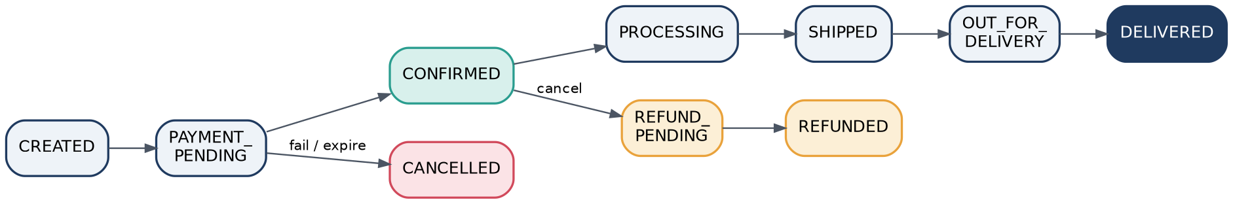
Order lifecycle (generated diagram)

6.10 Fulfilment, shipment and tracking
ID | Requirement | Pri
FR-63 | Confirmed orders are sent to fulfilment asynchronously. | M
FR-64 | Packing and processing status is tracked. | M
FR-65 | A shipment request is created for each fulfilment-ready order through a pluggable delivery-partner interface. | M
FR-66 | Failed shipment requests are retried without creating duplicate shipments. | M
FR-67 | Shipment and tracking updates (courier webhooks or polling) update the order status. | M
FR-68 | Failed delivery attempts are recorded and handled (retry or return). | S

6.11 Notifications
ID | Requirement | Pri
FR-69 | Customers are notified of reservation success, reservation expiry, sold-out, payment success and failure, order confirmation, shipment and delivery. | M
FR-70 | Notifications are asynchronous and never block checkout or order confirmation. | M
FR-71 | Failed notifications are retried; replayed events do not send duplicates. | M
FR-72 | Email, SMS, push and in-app channels are supported. | S

6.12 Events and messaging
ID | Requirement | Pri
FR-73 | Key business events are published: ReservationCreated, ReservationExpired, ReservationReleased, PaymentInitiated, PaymentSucceeded, PaymentFailed, OrderCreated, OrderConfirmed, OrderCancelled, ShipmentCreated, DeliveryStatusUpdated. | M
FR-74 | Each service consumes only the events that belong to its responsibility. | M
FR-75 | Consumers handle duplicate deliveries safely. | M
FR-76 | Messages that keep failing move to a dead-letter queue and raise an alert. | M
FR-77 | Critical events are never lost if a downstream service is down. | M

6.13 Administration and operations
ID | Requirement | Pri
FR-78 | Admins can schedule a sale with products, stock, price, per-user limit, reservation time, and start and end time. | M
FR-79 | A live dashboard shows available, reserved and sold stock, conversion, payments and failures. | M
FR-80 | A kill switch can pause a sale, and feature flags allow controlled degradation. | M
FR-81 | Operators can re-drive dead-letter messages and trigger reconciliation, with an audit record. | S
Reference note (idempotency): Stripe’s public API documentation describes the same approach: the result of the first request for a key is saved and replayed for later requests with that key, including error results; a key reused after the stored record has been pruned is treated as a new request; and a request that fails validation or conflicts with a request still running is not saved (R1). This is why FR-39 requires keeping records longer than the longest retry window, and why a request that is still in progress must be handled explicitly (reject with a conflict or wait).

7. Non-functional requirements
Each item is marked Guarantee (must never be broken) or Target (an engineering goal measured over time).

7.1 Correctness and consistency
ID | Requirement | Type
NFR-01 | Stock is never oversold: sales never exceed units available. | Guarantee
NFR-02 | Available stock is never negative, and available + reserved + sold = total. | Guarantee
NFR-03 | Reservation decisions per product are strictly ordered (one authoritative decision point). | Guarantee
NFR-04 | One logical request produces at most one reservation, one payment and one order. | Guarantee
NFR-05 | A reservation can never be both active and released. | Guarantee
NFR-06 | An order is never confirmed without confirmed payment and a valid reservation. | Guarantee
NFR-07 | Paid purchases are never lost: payment success always ends in a confirmed order or a refund. | Guarantee
NFR-08 | Fulfilment, shipment and notification may lag but converge within about 60 seconds when dependencies are healthy. | Target
NFR-09 | Stock shown while browsing may be up to about 2 seconds stale. | Target

7.2 Performance
ID | Requirement | Type
NFR-10 | Cached product and sale pages respond in 100–200 ms (p99 under 200 ms). | Target
NFR-11 | A reservation request (win or sold-out) gets an answer in about 300 ms normally and under 500 ms (p99) at peak. | Target
NFR-12 | Sold-out rejections at the fast path respond in under 100 ms. | Target
NFR-13 | Customers in the waiting room always see a queue position or status, never an endless spinner. | Target
NFR-14 | Order confirmation after payment success completes within about 5 seconds (p95) when healthy. | Target
NFR-15 | Payment confirmation, fulfilment, shipment and notification may finish asynchronously after checkout responds. | Target

7.3 Scalability
ID | Requirement | Type
NFR-16 | Handle 10,000 simultaneous purchase attempts through controlled contention. | Target
NFR-17 | Be designed for about 10,000 requests per second in normal high traffic. | Target
NFR-18 | Show how the design scales toward 500,000 requests per second through caching, admission control, horizontal scaling and asynchronous work. This is a design-reasoning target. | Target
NFR-19 | Stateless services scale out by adding instances, with pre-scaling before a scheduled sale. | Target
NFR-20 | Describe behaviour at 50 times current traffic: what scales, what is shed, what degrades. | Target
NFR-21 | Contention on a hot product is controlled by an atomic mechanism, not by adding database read capacity. | Guarantee
Likely bottlenecks: the hot inventory key or row, database connections, payment-provider rate limits, message-broker backlog, order-processing workers, and external shipment providers.

7.4 Availability and reliability
ID | Requirement | Type
NFR-22 | Browsing availability of at least 99.95% during a sale. | Target
NFR-23 | Checkout, payment and order availability of at least 99.9%; degrade safely rather than become inconsistent. | Target
NFR-24 | No data loss (RPO = 0) for stock, payments and orders in the SQL database (synchronous replication). The Redis stock gate is a fast filter, not the source of truth, because Redis replication is asynchronous by default and acknowledged writes can be lost in a failover (R6). | Guarantee
NFR-25 | Database failover within about 5 minutes and stateless service recovery within about 1 minute. | Target
NFR-26 | If non-critical services fail, essential operations continue (for example, a notification failure never cancels an order). | Guarantee
NFR-27 | Transient failures are retried a bounded number of times with exponential backoff and jitter. | Guarantee
NFR-28 | Unstable external services (payment, shipment) sit behind circuit breakers. | Guarantee
NFR-29 | Messages are delivered at least once and consumers are idempotent; poison messages go to a dead-letter queue. | Guarantee
NFR-30 | Stock, reservations, payments and orders are reconciled periodically. | Guarantee
Availability note: checkout can never be more available than its critical dependencies. With an external payment gateway in the path, the 99.9% target for checkout is only achievable if the gateway, database and broker each meet at least that level or if the design degrades gracefully around them (R10). Availability and latency targets should also be written as SLOs, for example “99% of reservation requests complete in under 500 ms”, rather than as averages (R8, R9).
Starting values for resilience policies (to be tuned in testing). Retries should happen at one layer only, with capped exponential backoff and jitter, because retries at every layer multiply load during an outage (R3):
Dependency | Timeout | Retry | Circuit breaker | Basis
Payment gateway | 5–8 s | Check status first, then at most 3 retries | Opens at 50% failures over 20 calls; half-open after 30 s | Team assumption. Choose the timeout from the gateway’s measured latency percentiles (R3); tune breaker values to its recovery pattern (R4)
Order Service (async) | Event driven | Backoff for up to about 15 minutes, then dead-letter | Per consumer | Pattern is established (R2, R12); the 15-minute window is a team assumption
Notification providers | 3 s | Up to 5 retries, then dead-letter | Per provider | Team assumption
Shipment provider | 5 s | Idempotent retries | Per partner | Team assumption

7.5 Security
ID | Requirement | Type
NFR-31 | Use HTTPS/TLS for all external traffic and secure channels (mTLS or signed calls) between services. | Guarantee
NFR-32 | Every protected API requires authentication, and customers see only their own carts, reservations, payments and orders. | Guarantee
NFR-33 | Validate every field, quantity, identifier and state transition. | Guarantee
NFR-34 | Rate limiting and abuse protection at the CDN/WAF and gateway. | Guarantee
NFR-35 | Never store raw card data; use a hosted, redirect or embedded payment page from a PCI DSS-validated provider. This reduces PCI scope but our own site remains in scope (R11). | Guarantee
NFR-36 | Keep API keys and credentials in a secrets manager and rotate them. Encrypt personal data at rest. | Guarantee
NFR-37 | Keep an append-only audit log with actor, timestamp, correlation ID and result. | Guarantee
NFR-38 | Verify webhook signatures and protect against replay. | Guarantee

7.6 Observability
Metrics: request rate, latency (p50, p95, p99), error rate, queue length, waiting-room size, reservation successes and failures, sold-out count, reservation expiries, payment successes, failures and timeouts, order creation delay, message backlog, dead-letter count, and inventory mismatch count.
Structured logs carry correlation_id, request_id, user_id, product_id, reservation_id, payment_id, order_id, event_id, operation, status, timestamp and error_code.
Tracing follows a purchase through the API gateway, Inventory, Checkout, Payment, Order, message broker and Fulfilment.
Alerts fire for: negative or inconsistent inventory, high reservation failure rate, payment failure spike, payment and order mismatch, growing queue backlog or message age, Order Service unavailability, repeated dead-letter messages, and open circuit breakers.

8. Architecture overview and technology

8.1 How a request flows
Traffic is controlled at the edge, stock is reserved atomically, payment is processed idempotently, orders are created through reliable events, and every incomplete workflow is recovered by retries and reconciliation.
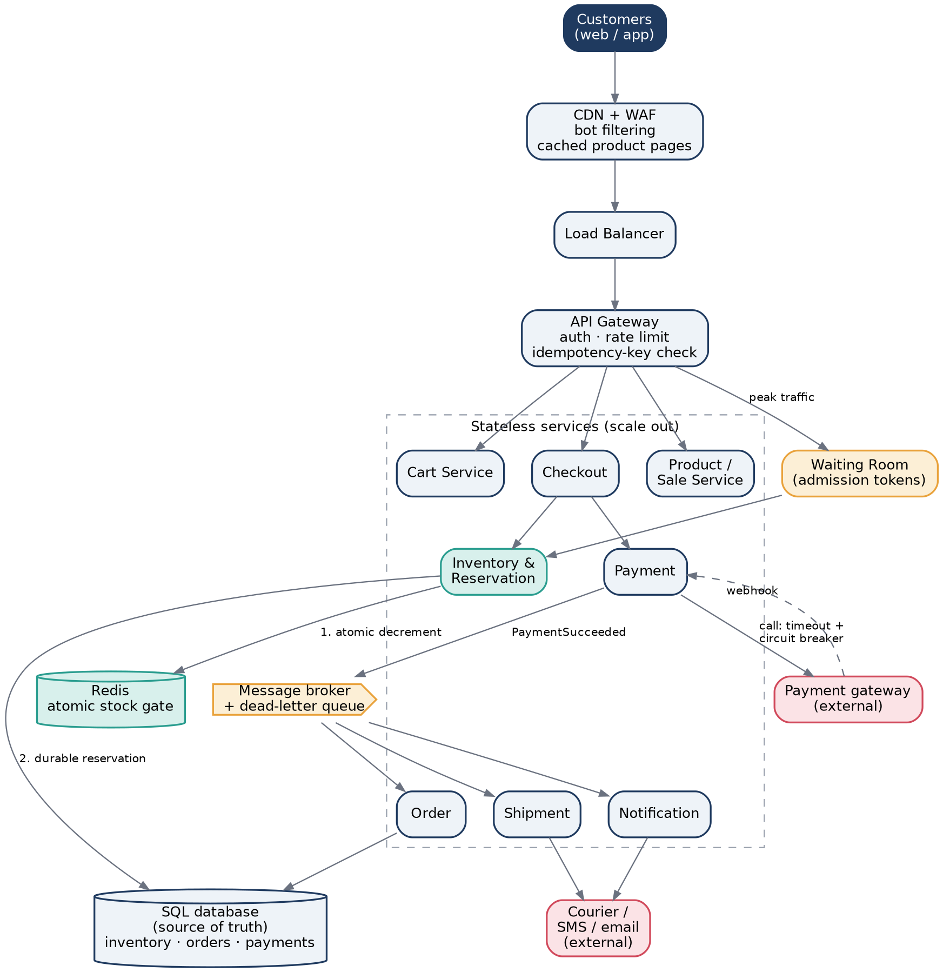
Reference architecture (generated diagram)
Why each major piece exists
- CDN and WAF: serve cached pages and block bots so that most traffic never reaches our servers.
- API gateway: authentication, rate limits and the idempotency-key check in one place.
- Waiting room: turns a stampede into a controlled queue.
- Inventory and Reservation Service with a Redis stock gate: one fast, atomic point where “who gets the unit” is decided. The SQL database stays the durable source of truth.
- Message broker with dead-letter queue: decouples payment, orders, shipment and notifications so that one slow service cannot stop the others.
- Circuit breakers and webhooks: protect us from, and recover with, the payment gateway.

8.2 Transaction boundaries
Operation | Boundary | How it stays safe
Reservation | Check stock + reduce available stock + create reservation, as one atomic operation (database transaction, conditional update, row lock or atomic cache operation plus durable write; the choice is justified in design) | All-or-nothing; no partial reservation
Payment | Outside the local transaction because the gateway is external | Idempotency key, status lookup, webhook, event de-duplication and reconciliation
Order | Order state change and outbox event in one local transaction | The event is never lost even if publishing is delayed
Release | Conditional: “release only if the reservation is currently active” | Safe to repeat

8.3 Candidate technologies
Technology is not fixed at this stage; what matters is that the choice satisfies the requirements. Logos below come from the projects’ official repositories.
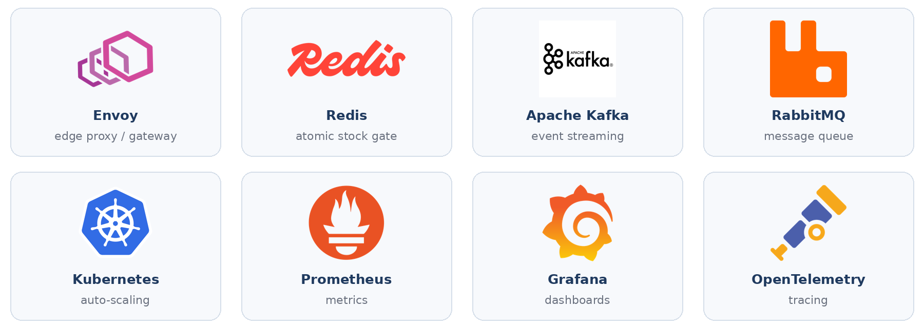
Candidate technologies (logos from official project repositories)
Concern | Candidates
API services | Spring Boot, FastAPI, Node.js or ASP.NET Core
Relational database | PostgreSQL or MySQL
Atomic stock gate and cache | Redis
Message broker | Kafka, RabbitMQ or Amazon SQS
Orchestration and scaling | Kubernetes
Load testing | k6, Locust or JMeter
API documentation | OpenAPI / Swagger
Monitoring and tracing | Prometheus, Grafana, OpenTelemetry

9. Data requirements

9.1 Main entities
Entity | Purpose
CUSTOMER | Identity and account
PRODUCT, CATEGORY | Catalogue
INVENTORY | Available, reserved and sold quantities
INVENTORY_RESERVATION | Temporary hold, status, expiry and idempotency key
CART, CART_ITEM | Shopping cart
ORDER, ORDER_ITEM | Confirmed purchase and line items
PAYMENT | Payment transaction and state
SALE, DEAL, COUPON | Sale and promotion rules
SHIPMENT | Fulfilment and delivery data
NOTIFICATION | Customer messages
AUDIT_LOG, OUTBOX_EVENT, IDEMPOTENCY_RECORD, PROCESSED_EVENT | Traceability, reliable messaging, de-duplication

9.2 Concurrency-critical fields
Field | Purpose
inventory_id, product_id | Identify the stock record and its product
available_quantity, reserved_quantity, sold_quantity | Where every unit currently is
version | Concurrency / version control
updated_at | Last change
reservation_id, expires_at | The hold and when it ends
idempotency_key | Duplicate-request prevention

9.3 Integrity rules
- Primary keys on every entity and foreign keys between product, customer, reservation, order and payment.
- CHECK (available_quantity >= 0 AND reserved_quantity >= 0 AND sold_quantity >= 0).
- Unique (idempotency_key, customer_id) on reservations and payments; unique reservation_id on orders.
- Indexes on product_id, (status, expires_at) for expiry sweeps, customer_id, order_id, and the external transaction reference.
- Audit columns (created_at, updated_at, created_by) and status-history tables for reservations, orders and payments.
- Transactional outbox so that an event and its state change are saved together.
- Orders and payments are retained as financial rules require; personal data is encrypted; logs never contain card data or secrets.

10. Worst-case scenarios and how we handle them
Good design is mostly about the bad days. Every scenario below is something that can realistically happen during a flash sale, with the damage it would cause if ignored and the safeguard that stops it.

10.1 Traffic and edge
ID | Worst case | If ignored | Solution and safeguard
W-01 | Traffic is 50× the forecast | Servers and database collapse; everyone gets errors | Cache pages at the CDN, apply admission control and the waiting room, shed low-value traffic first (browse, recommendations) to protect payment and order, autoscale stateless tiers, keep the hot-product path serialised
W-02 | Everyone hits the site the instant the sale opens (thundering herd) | Cold caches and a database stampede | Pre-warm caches, pre-scale capacity, stagger entry through a virtual waiting room (AWS publishes a reference solution, R7), serve the sale page as static content
W-03 | Bots and scripts grab the stock | Real customers lose; load spikes | WAF and bot detection, CAPTCHA at admission, per-user and per-IP limits, one unit per customer, signed admission tokens
W-04 | A DDoS attack at the edge | Site unavailable | CDN and WAF absorption, rate limiting, geo and reputation rules, emergency kill switch
W-05 | Load balancer or API gateway instance fails | Dropped requests | Multiple instances across zones, health checks, automatic replacement, client retries with idempotency keys
W-06 | The waiting room itself overloads | Customers stuck or locked out | Serve it from the CDN or an independent service, issue signed tokens, allow it to be bypassed only by operators

10.2 Inventory and reservation
ID | Worst case | If ignored | Solution and safeguard
W-07 | Two customers want the last unit at the same instant | Both succeed, so one unit is sold twice | Atomic “check and decrement” at a single decision point; exactly one wins and the other gets sold-out
W-08 | 10,000 requests on one hot stock row | Lock contention, timeouts, a stuck database | Redis atomic gate takes the rejections (Redis runs a script atomically, R5), only about 100 winners reach the database; conditional update WHERE available >= qty; sold-out flag short-circuits the rest
W-09 | Reservation created but the app crashes before replying | The customer retries and gets a second hold, or loses the unit | Idempotency key returns the original reservation; hold expires if never used
W-10 | Reservation expires at the exact moment payment succeeds | Customer pays for stock that was released and resold | Conditional state change: confirm only if still active; otherwise re-reserve if stock exists, else automatic refund
W-11 | Expiry worker crashes or falls behind | Phantom sold-out; stock stuck in “reserved” | Multiple workers with idempotent release, lag metric and alert, reconciliation job that recounts stock
W-12 | Stock released twice | Phantom units are created and oversell follows | Release only if status is currently active; unique release record; invariant check available + reserved + sold = total
W-13 | Redis counter and database disagree | Oversell or undersell | Database is the source of truth, reservation writes are durable, periodic reconciliation, alert on any mismatch, rebuild counters from the database
W-14 | Redis fails or restarts mid-sale | Stock gate lost | Fail closed (pause new reservations) or fall back to a conditional database update at a lower rate; rebuild counters from reservations; use a replica with automatic failover, but remember that Redis replication is asynchronous, so the database must stay the final authority (see W-51)
W-15 | Inventory database primary fails | Writes stop; risk of unsafe decrements | Synchronous replica with automatic failover (RPO = 0), reject or queue reservations during failover, never decrement without a durable write, verify the invariant after recovery
W-16 | A customer hoards or opens many accounts | Stock goes to one buyer | Per-customer limit enforced on the server, bot and identity checks, payment-instrument and address limits
W-17 | Admin changes stock during the sale | Counters drift | Stock adjustments go through the same atomic path, are audited, and require approval
W-18 | Cart items assumed to be reserved | Customers believe they own stock and are refused at checkout | Cart never holds stock; only an explicit reservation does; the UI says so

10.3 Duplicate and replayed requests
ID | Worst case | If ignored | Solution and safeguard
W-19 | Double-click on Buy Now (about 2% of requests) | Two reservations or orders | Idempotency key plus request owner; second request replays the first response
W-20 | Mobile app retries after a timeout | Duplicate side effects | Every state-changing API requires an idempotency key; clients reuse the same key for retries
W-21 | Same key reused with different data | Wrong operation is replayed | Reject with a conflict error (FR-38)
W-22 | Duplicate webhook or duplicate broker message | Order or notification processed twice | Processed-event table with unique event ID; consumers are idempotent
W-23 | Idempotency record deleted too early | A late retry becomes a new purchase | Keep records longer than the maximum retry window; Stripe documents that a key reused after its record is pruned is treated as a new request (R1)

10.4 Payment
ID | Worst case | If ignored | Solution and safeguard
W-24 | Payment fails (about 5%) | Stock stays locked until timeout | Release the reservation immediately, mark the order PAYMENT_FAILED, notify the customer, re-offer the unit to the waitlist
W-25 | Payment times out (result unknown) | Customer charged twice, or told “failed” while charged | Treat as unknown; query provider status; reuse the same idempotency reference for any retry; reconcile before releasing or confirming
W-26 | Customer pays twice (retry, second tab) | Duplicate charge | One payment reference per checkout; duplicate returns the existing transaction; auto-refund any extra settlement found by reconciliation
W-27 | Payment gateway is down or very slow | Threads pile up, checkout stalls, reservations expire unpaid | Timeouts, circuit breaker opens (R4), friendly “payment temporarily unavailable” message, optionally extend hold, queue and retry, secondary provider through the abstraction
W-28 | Gateway reports success but our webhook is lost | Customer paid but we show unpaid | Poll or query status for pending payments, daily settlement reconciliation
W-29 | Webhook is forged or replayed | Fake “paid” orders | Signature verification, timestamp checks and event de-duplication; confirm with the provider before trusting it
W-30 | Browser says “paid” but the server never confirmed | Order without money | Server-side confirmation only (BR-08)
W-31 | Payment succeeds after the reservation expired | Customer charged for no stock | Re-reserve if stock remains, otherwise automatic refund and apology notification
W-32 | Refund fails or is delayed | Customer charged and unhappy | Refund state machine with retries, finance queue and alerts, customer-visible status

10.5 Order, fulfilment and messaging
ID | Worst case | If ignored | Solution and safeguard
W-33 | Payment succeeds but the Order Service is down (30 s) | Paid purchase is lost | Payment event written to the outbox and broker; consumer retries with backoff until the order exists; idempotent order creation by reservation ID; customer shown “confirming”
W-34 | Order Service stays down much longer | Backlog and unhappy customers | Durable queue keeps events, queue-age alert, autoscale consumers, reconciliation job, and after a defined limit auto-refund
W-35 | Order created twice from a retry | Two shipments | Unique constraint reservation_id on orders
W-36 | Message broker outage | Events cannot be sent | Transactional outbox keeps events in the database until the broker returns (R2); broker clustered across zones
W-37 | Poison message keeps failing | Consumer blocked or infinite retry loop | Bounded retries, then dead-letter queue (for example SQS maxReceiveCount, R12), alert, and operator re-drive tool; keep DLQ retention longer than the source queue so parked messages do not expire before review
W-38 | Events arrive out of order | A “shipped” update arrives before “confirmed” | State machine rejects invalid transitions, events carry sequence numbers and versions
W-39 | Fulfilment or courier API is down | Orders stuck at confirmed | Retry with circuit breaker, idempotent shipment creation, alternate delivery partner through the adapter
W-40 | Notification service fails | No emails, support overloaded | Notification never blocks the order; retries and dead-letter; in-app status as backup
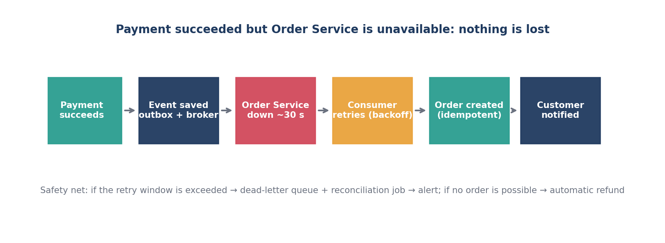
Recovery path when payment succeeds but the Order Service is unavailable (generated diagram)

10.6 Infrastructure, data and operations
ID | Worst case | If ignored | Solution and safeguard
W-41 | Database connection pool exhausted | All services time out | Connection pooling and limits, bulkheads per service, admission control upstream, read replicas for reads
W-42 | Network partition between services | Split decisions | Single authoritative inventory owner, fail closed for reservations, timeouts with idempotent retries
W-43 | A whole availability zone fails | Capacity and data loss | Multi-AZ deployment, replicated data, health-checked load balancing; multi-region as a documented next step
W-44 | Bad deployment during the sale | Outage or wrong prices | Change freeze before sale, canary or blue-green releases, instant rollback, feature flags
W-45 | Wrong price or sale configuration | Revenue loss or legal issues | Server-side pricing, admin approval, sale preview, kill switch
W-46 | Clock drift between servers | Reservations expire early or late | Use database or central time for expiry; NTP monitoring
W-47 | Logs, metrics or tracing system fails | Blind during an incident | Buffered, asynchronous telemetry that never blocks requests; database audit trail as backup
W-48 | Security incident or credential leak | Data exposure | Secrets manager and rotation, least privilege, audit log, encryption, incident runbook
W-49 | Operator error (wrong stock, wrong manual repair) | Inventory corruption | Audited admin actions, approval for stock changes, reconciliation and invariant alerts
W-50 | Monitoring detects drift late | Overselling goes unnoticed | Real-time invariant check available + reserved + sold = total, alert on any mismatch, automatic pause of the sale

10.7 Additional cases found while checking sources
ID | Worst case | If ignored | Solution and safeguard
W-51 | Redis fails over and loses recent stock decrements (acknowledged writes can be lost because replication is asynchronous, R6) | The gate believes more stock exists than the database does, or the opposite | The database is the only source of truth: every winner must still pass the conditional database update WHERE available >= qty, so extra winners are rejected safely. Rebuild the Redis counter from the database after any failover. Accept that a few customers may see “reservation failed” rather than risk overselling
W-52 | Outbox table grows without limit or the relay falls behind (R2 and practitioner write-ups note polling load and the need for pruning) | Events delayed, database slowed | Index unpublished rows, prune published rows, monitor relay lag, consider log-based change capture instead of polling, alert on oldest unpublished event
W-53 | Retry storm: every layer retries during an outage | Retries multiply load and turn a small failure into a full outage (R3) | Retry at one layer only, capped exponential backoff with jitter, a retry budget or token bucket, and circuit breakers; shed load rather than retry harder

11. Acceptance scenarios
# | Scenario | Expected behaviour
AC-1 | 10,000 customers request 100 units | Exactly 100 reservations succeed; 9,900 get sold-out; no negative stock
AC-2 | A successful purchase | Reserve, check out, pay, order CONFIRMED, stock SOLD, customer notified
AC-3 | A failed payment | Reservation released, stock returns, order PAYMENT_FAILED, customer notified
AC-4 | A duplicate Buy request | The original reservation is returned; reserved count unchanged
AC-5 | A duplicate payment request | Same transaction returned; one charge only
AC-6 | Payment success and Order Service down 30 s | Event retained, order created after recovery, no loss and no duplicates
AC-7 | Stock reaches zero | Sold-out flag set; later requests rejected cheaply; sold-out and waitlist message shown
AC-8 | A reservation expires | Unit released exactly once; late payment is re-reserved or refunded
AC-9 | Payment timeout | State PAYMENT_UNKNOWN; resolved by status check; no duplicate charge
AC-10 | Payment gateway outage | Circuit breaker opens; customers see a clear message; queued retries after recovery
AC-11 | Database primary fails | Failover with no data loss; invariant verified; no oversell
AC-12 | Redis fails | Fail closed or use the durable fallback; counters rebuilt from the database
AC-13 | Traffic grows 50× | Admission control, shedding, autoscaling; payment and order protected first
AC-14 | A consumer crashes and messages are redelivered | Duplicates ignored; poison messages sent to dead-letter

12. Design constraints and principles
- Inventory correctness matters more than accepting every request.
- After stock is exhausted, the system may queue or reject customers.
- The customer’s browser is never the source of truth for payment.
- A timeout never means “payment failed”.
- A cart is never a reservation unless explicitly designed to be.
- Every externally retried operation with a side effect is idempotent.
- Asynchronous processing must never hide failed messages: they must be monitored.
- Raw card details are never stored.
The central idea: control traffic at the edge, reserve inventory atomically, process payment idempotently, create orders through reliable events, and recover every incomplete workflow through retries and reconciliation. The system does not try to make every customer successful. It makes sure that limited stock is allocated safely and fairly, repeated actions are harmless, and every valid purchase is eventually completed.

13. Open questions
- Is the per-customer limit fixed at one unit or configurable per sale?
- Should released units go to a waitlist first or reopen to everyone?
- Should the hold be extended while a payment is in progress?
- Is the stock authority the in-memory store or the database? Decide by comparing optimistic locking, pessimistic locking and an atomic counter.
- Which broker and delivery guarantees will carry the outbox and event bus?
- For late payment after expiry, is re-reserve or refund the first choice?

Appendix A — Glossary
Term | Meaning
Hot SKU | A product with extreme simultaneous demand
Reservation | A temporary hold on stock with an expiry time
Idempotency | Repeating a request gives the same result and no extra side effects
Outbox pattern | An event is saved in the same transaction as the state change and published reliably afterwards
Dead-letter queue (DLQ) | Where messages that keep failing are parked for review
Circuit breaker | Stops calling a failing service so the failure does not spread
Reconciliation | Comparing two records of the same truth (for example gateway versus our payments) and fixing differences
RPO / RTO | Maximum tolerated data loss / maximum tolerated recovery time
Oversell | Selling more units than physically exist
Waiting room | A queue that admits customers into the purchase flow at a safe rate

Appendix B — Image sources
Technology logos (Envoy, Kafka, Kubernetes, OpenTelemetry, Prometheus, Grafana, Redis, RabbitMQ) were downloaded from the official project repositories on GitHub (CNCF artwork repository, Apache Kafka site repository, Grafana, Redis and RabbitMQ repositories) and remain trademarks of their respective owners. All other diagrams were generated for this document.

Appendix C — Evidence and provenance
This appendix answers a fair question: which parts of this document rest on proven practice, and which parts are judgment calls?

C.1 Legend
Label | Meaning
Given | Stated in the problem brief
Team brief | Supplied by the team’s own requirements text
Established practice | Documented by a vendor, standards body or well-known engineering reference (see Appendix D)
Team assumption | A reasonable starting value or decision with no external source; validate by testing

C.2 Evidence map for design decisions
Design decision | Basis | Reference
Idempotency keys; replay the original result for repeats | Established practice (vendor-documented) | R1
Transactional outbox plus idempotent consumers (outbox gives at-least-once delivery, so duplicates must be handled by the receiver) | Established practice | R2
Timeouts, capped exponential backoff with jitter, retry at one layer | Established practice | R3
Circuit breaker with closed, open and half-open states, separate from retry | Established practice | R4
Atomic stock decrement using a server-side script | Vendor-documented: Redis runs scripts atomically | R5
Redis as a fast gate but not the source of truth | Vendor-documented: replication is asynchronous and acknowledged writes can be lost on failover | R6
Virtual waiting room to absorb a surge | Established practice (AWS publishes a reference solution) | R7
Express targets as SLOs and avoid averages; availability is limited by dependencies | Established practice | R8, R9, R10
Hosted, redirect or iframe payment pages to reduce PCI scope | Standards body guidance | R11
Dead-letter queue with a maximum receive count and redrive | Vendor-documented | R12
Conditional SQL update WHERE available >= qty, reservation TTL with expiry sweeper, reconciliation, per-customer limit, sold-out fast path, order and reservation state machines | Standard engineering practice, no single authoritative source; to be validated by simulation | none
The 53 worst-case scenarios in section 10 | Team synthesis of known failure modes in payment, messaging and inventory systems | R1 to R12 support individual items

C.3 Provenance of the key numbers
Value | Basis | Note
100 units, 10,000 concurrent requests, 95% / 5% payment split, 2% duplicates, 30 s Order Service outage | Given | From the problem brief
10,000 rps normal and up to 500,000 rps flash-sale ceiling, 50× stress | Given | Design-reasoning targets, not a measured result
5-minute reservation hold, one unit per customer | Team brief | Business choice; tune per sale
Browse availability 99.95% | Established practice (example) | A Google SRE blog post uses 99.95% as an example web availability SLO (R9); still a target to confirm
Checkout availability 99.9% | Team assumption | Bounded by the payment gateway and other dependencies (R10)
Latency targets (100–200 ms browse, 300 ms typical and 500 ms p99 reservation, 100 ms sold-out path) | Team assumption | Validate with load tests; express as SLOs (R8, R9)
RPO = 0 for the SQL database | Design goal | Achievable with synchronous replication; not true for Redis (R6)
Failover 5 min, stateless recovery 1 min | Team assumption | Depends on the managed database and platform
Gateway timeout 5–8 s | Team assumption | Derive from measured gateway latency (R3)
At most 3 payment retries, 5 notification retries, 15-minute order retry window | Team assumption | Counts and windows are tunable; the pattern is established (R2, R3, R12)
Circuit breaker: 50% failures over 20 calls, 30 s before half-open | Common defaults, team tuned | Tune to the dependency’s recovery pattern (R4)
Stock display staleness 2 s, order confirmation p95 5 s, convergence 60 s | Team assumption
Idempotency record retention | Team assumption | Must exceed the longest retry window; Stripe prunes old keys (R1)

C.4 What these sources do not prove
- They do not prove that this exact architecture will hold 10,000 simultaneous requests or 500,000 requests per second. That has to be shown by load testing or simulation of the hot-stock path.
- They do not supply flash-sale specific numbers such as reservation hold time or per-customer limits.
- Vendor documents (Stripe, Redis, AWS, Microsoft) describe their own products; the patterns are general, but configuration values are not portable without testing.
- The worst-case catalogue is not exhaustive. Treat it as a starting checklist and add cases found in testing and incident reviews.

Appendix D — References
These sources were located and read through web search on 5 October 2026. Web pages change, so open each link to confirm the current wording before quoting it.
Ref | Source | Used for
R1 | Stripe API documentation, “Idempotent requests”. https://docs.stripe.com/api/idempotent_requests | Idempotency keys, replaying the first result, key pruning
R2 | Chris Richardson, microservices.io, “Pattern: Transactional outbox”. https://microservices.io/patterns/data/transactional-outbox | Atomic state change plus event, message relay
R3 | Marc Brooker, Amazon Builders’ Library, “Timeouts, retries, and backoff with jitter”. https://aws.amazon.com/builders-library/timeouts-retries-and-backoff-with-jitter | Timeouts, capped backoff, jitter, retry layering
R4 | Microsoft Azure Architecture Center, “Circuit Breaker pattern”. https://learn.microsoft.com/azure/architecture/patterns/circuit-breaker | Breaker states, difference from retry
R5 | Redis documentation, “Scripting with Lua”. https://redis.io/docs/latest/develop/programmability/eval-intro/ | Atomic script execution
R6 | Redis documentation, “Redis replication”. https://redis.io/docs/latest/operate/oss_and_stack/management/replication/ | Asynchronous replication, possible loss of acknowledged writes
R7 | AWS Solutions, “Virtual Waiting Room on AWS”. https://docs.aws.amazon.com/solutions/latest/aws-virtual-waiting-room/welcome.html | Waiting room for traffic bursts such as sales
R8 | Google, Site Reliability Engineering, chapter 4 “Service Level Objectives”. https://sre.google/sre-book/service-level-objectives | SLI, SLO and SLA definitions
R9 | Google Cloud blog, “Building good SLOs (CRE life lessons)”. https://cloud.google.com/blog/products/gcp/building-good-slos-cre-life-lessons/ | Latency SLO as a percentage under a threshold; example availability figures
R10 | Google, “The Calculus of Service Availability”. https://sre.google/static/pdf/calculus_of.pdf | Availability limited by critical dependencies
R11 | PCI Security Standards Council FAQ, direct post versus iFrame and URL redirect. https://www.pcisecuritystandards.org/faq/articles/Frequently_Asked_Question/Why-is-there-a-different-approach-for-Direct-Post-implementations-than-for-iFrame-and-URL-redirect-what-are-the-technical-differences-and-how-do-they-impact-the-security-of-e-commerce-transactions | Hosted and redirect payment pages and SAQ A
R12 | Amazon SQS Developer Guide, “Using dead-letter queues in Amazon SQS”. https://docs.aws.amazon.com/AWSSimpleQueueService/latest/SQSDeveloperGuide/sqs-dead-letter-queues | Dead-letter queues, max receive count, redrive

